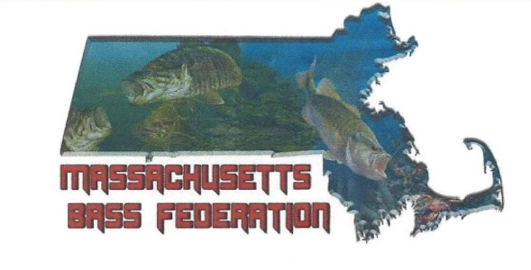
2021 Massachusetts Bass Federation
State Championship Entry Form and Rules
- All Clubs sending a Team must have ALL Club Members current FLW and TBF numbers to be eligible. No Exceptions.
- All Entry Forms Must be Postmarked by July 10th, 2021.
- All Clubs shall supply a hostage Check in the amount of $200.00 made out to the Massachusetts Bass Federation prior to or with entry forms. In the event an angler from your club does not show without prior authorization, this fee will be retained by the Federation.
- The Lake is not off-limits to Federation Members this year. Official Practice is Friday from Dawn till 3 PM. ALL TOURNAMENT RULES APPLY.
- Pre-Tournament Meeting begins promptly at 5:00pm location to be announced.
- Tournament Headquarters will be announced. Any changes in the Pairings after Day 1 will be made that location. Captains Meeting will be at 7:30pm if needed.
- It is Mandatory to provide Hotel, Room and Phone numbers and Cell Phone numbers for every entry.
- The Entry Fee is $200.00 and may be paid by check made out to Mass Bass. This must be a separate check from the hostage check.
- Optional Lunker fee is $20 and must be paid in cash at the Pre-Tournament meeting.
- Bring a copy of your New York Fishing License and a copy of your boat insurance to the Registration Meeting. NO Exceptions!
- If you are bringing your boat and wish to be considered for a boater spot if one is available, Make a note on your entry form, and provide insurance. Please be aware if you fish as a boater for one day you will be competing against the boaters.

Pairings meeting site will be announced at Federation meeting prior to the Championship.

Please read all of the rules on these pages, as they apply to everyone!

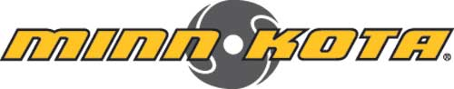

2021 Massachusetts Bass Federation State Championship Rules

All participants are responsible for knowing all rules, no exceptions

You Must Have A Valid New York License To Fish This Tournament

. • Any and all problems or questions will be answered by the Tournament Director •

. • All Federal and State boating and fishing rules apply. •

. • All Federation applicable tournament rules apply, including the pages of this document. •

. • Please pay strict attention to all “NO WAKE” areas. There are several NO WAKE areas that are heavily patrolled. •

Off Limits: The water will not be off limits prior to this tournament. Official practice shall be Friday for this year’s Championship and is considered part of the tournament. This day is to be treated just like a tournament day with all Federation rules applying. All kill switches and life jackets must be worn etc. Practice shall end at 3:00 P.M. Friday.

Pre-Tournament Practice: For 30 days prior to and during the tournament a competitor cannot:

  - Be on the water with or solicit information from a known guide or local expert.

  - Have the assistance or advice of a professional guide; State or Federal Wildlife agency employee, or any other person deemed a "local expert" on these tournament waters by the Tournament Director, unless he is a contestant in the tournament.

Each competitor agrees to report to the Tournament Director any violation or infraction of these Tournament Rules. The failure to report violations or suggestions to violate these rules or false verification of weigh-in forms will be cause for disqualification. The penalty for any infraction of this rule is a one-year or more suspension from all Federation events.

Launch and take off on Saturday and Sunday will be from Broadalbin New York Access Area.
All boats will be checked for operating live-wells and kill switches.

The live-well CHECK will be the responsibility of the non-boater.

    - All boats must have a back seat for the non-boater to use if he or she so requires one.

    - Anytime the main motor is running, life vests and kill switch must be worn, no exceptions especially at ramps. Failure to comply will result in disqualification. Non-boaters shall supply their own life vests.

    - Nets will be allowed for use by all participants. Boaters must provide a suitable net. You are responsible for your own “netting”. If you choose to have someone else help they will be relieved of any responsibility for lost fish.

    - Minimum length fish will be 12” with a penalty for weighing a short fish and dead fish. Limit is five fish per day per participant but will be dropped to 4 fish if weather or fish kill dictates.

    - Launch times will be by boat number and by designated times.

    - No boat will be launched unless non-boater is in boat or physically present.

    - Non-boaters will be responsible for dropping boat/boater into water and then parking vehicle in designated location.

    - Each clubs anglers will be responsible for registration of themselves. This includes a copy or original STATE fishing licenses, a copy of boat insurance for all boaters (min. $300,000 liability).

    - You will enter the water from the designated launch ramp and must return to the same ramp at check out.

    - All boats must check out and in with the check-in boat. All fish will be release at the check-in boat and the boater must tell check-in boat he is releasing fish and be checked off. Failure to release fish at the check-in boat will mean disqualification for the boater.

    - All boats will be checked for operating live-wells and kill switches.

    - Boaters will have total control of the boat, both for fishing areas and control of the trolling motor. Non-boater may only use the trolling motor in case of emergency or injury. Non-boaters will fish from the back deck.

- All participants will be held to the highest standard of sportsmanship at this event. If a boater or non-boater takes you to their spot you may only return there with their permission.

- Use of cell phones during the fishing hours will be for safety or business use only. You may not use cell phones to talk to other anglers about locating fish or baits.

- Sportsmanship: All tournament competitors are expected to follow the highest standard of sportsmanship, courtesy, safety and conservation. Any infraction of the fundamental principles of good sportsmanship or STATE FISHING OR BOATING REGULATIONS may be deemed cause for disqualification. Maximum courtesy must be practiced at all times, especially with regard to boating and angling in the vicinity of non-competitors who are on the tournament waters. All bass must be caught alive and in a sporting manner. Anyone caught intentionally snagging fish will be immediately disqualified and can face further disciplinary action from the Federation. Any act by a competitor, which reflects unfavorably upon the Federation’s effort to promote fisheries conservation, clean waters and courtesy shall be cause for disqualification. Drunkenness of any Competitor during the tournament will not be tolerated and shall be cause for automatic disqualification from this and future Massachusetts Bass Federation tournaments. No alcoholic beverages or any other depressants or stimulants, shall be tolerated in the boats or at the weigh-in areas.

- All applicable Mass Bass Federation Trail Rules apply to this event. All State law also Apply to this event.

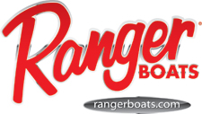
Massachusetts Bass Federation Event Participant Waiver

Having fully acquainted myself with the rules, and by signing this application, and by my presence at the events, I hereby agree to be bound by and comply with all event rules and safety regulations. I expressly assume all risks associated with the events and I hereby release The Bass Federation, Inc., (TBF) its parent, and affiliate companies, its licensees and affiliates, including their affiliated State federations, and clubs and all their respective officers, directors, agents employees and stockholders, the tournament hosts, sponsors and tournament officials from all claims of death, injury and/or property damage incurred in connection with this their events. If I am using a boat during the official practice days or during the tournament, I certify that I now have or will obtain prior to the event, property damage/watercraft liability insurance having a limit of at least $300,000. Said insurance must be issued by a reputable insurer and must cover injury and/or damage incurred in connection with this tournament. Upon request, I will provide satisfactory evidence of that insurance. I hereby wave my rights of privacy or publicity with regard
to the unconditional right to use my name, voice photographic likeness, video and biographical information and fishing tips and instructions in connection with any reproduction of same, video/audio productions and/or articles and press releases by TBF, its parent or affiliate companies, and those acting under their permission, anywhere at any time, through any medium or media. I shall not be entitled to receive any royalties or other compensation in connection with such use. I further understand and agree that the tournament officials reserve the right to reject my application for any reason.

Dated

Participant Printed

Participant Signed

For High School Anglers
HSA Parent or Guardian Signature

2021 Massachusetts Bass Federation
State Championship Entry Form
All Entry Forms Must be Postmarked by July 10th, 2021
Please Print Clearly

Return form with payment to; Joe McKinnon, 178 Charles St Waltham MA 02453

Club Name

Boater Number Non-boater Number

Name

FLW # TBF #

Hotel Phone/Room #

Cell Phone # Mandatory

Boat Make/Length Engine Make/HP
Brand of Electronics Model

Brand of Trolling Motor Model

Ranger Cup Yes No

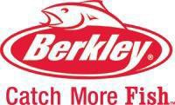
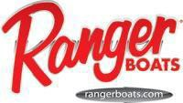
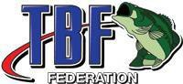
Anglers Signature Your signature confirms your acceptance of the rules for this tournament.

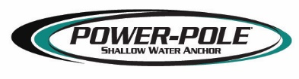

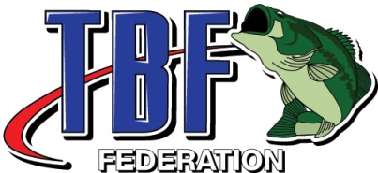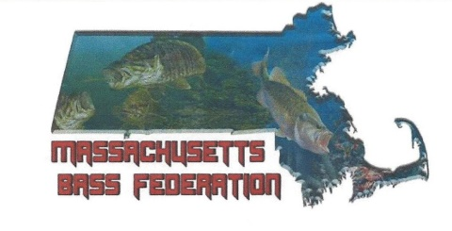
2021 State Championship Survey

Did you practice before the event? Yes No

If yes, how many days/nights did you spend in New York for practice?

If yes, how much money do you estimate that you spent on lodging, fuel (boat and tow vehicle) and food etc. in New York for practice?

How many nights did you stay in New York for the tournament?

How much money do you estimate that you spent on lodging, fuel (boat and tow vehicle) and food etc. in New York for the tournament?

Other than the fishing what did you like/dislike about the event?

Other than the location, what would changes would you like to see for this event?

Thank you for your input. This will help with future events.

Please print fill out and turn in at the pairings meeting

